COAL LAB 9

Q1)

INCLUDE Irvine32.inc

.data

.code

main PROC

mov eax,32

mov ebx,32

mov ecx,32

SHL eax,4

SHL ebx,2

SHL ecx,0

add eax,ebx

add eax,ecx

call writeDec

exit

main ENDP

END Main

Q2)

Include Irvine32.inc

.code

Main PROC

mov eax,0

mov ebx,0

mov ecx,3

mov esi,0

mov ax,-128

ror eax,16

sar eax,16

call writeint

call crlf

call writebin

call crlf

exit

main ENDP

END main

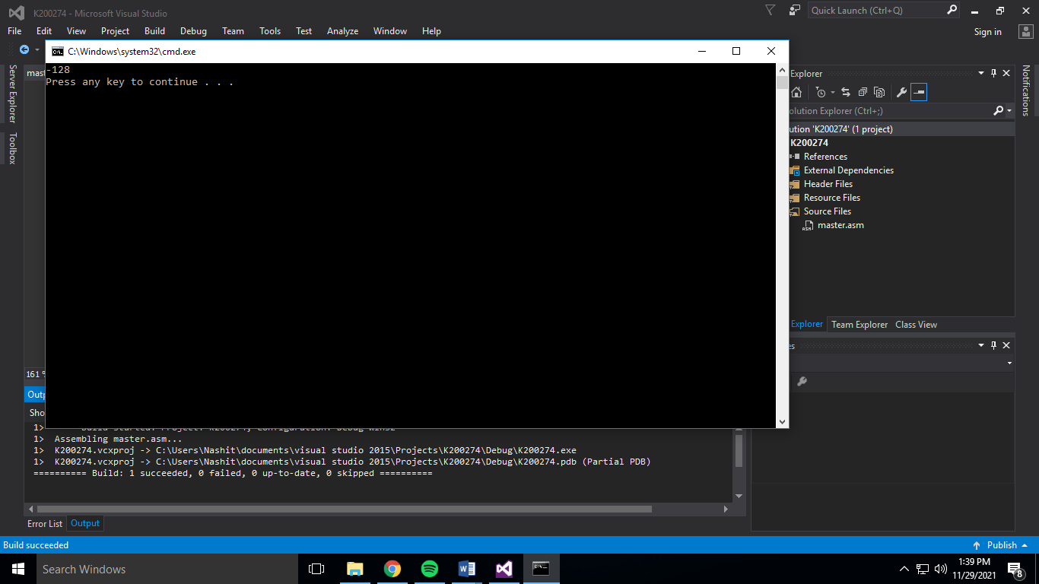

Q3)

Include Irvine32.inc

.code

Main PROC

mov eax,0

mov ax,0101101101011010b

mov dx,0000011111100000b

and ax,dx

shr ax,5

call writebin

call crlf

call writeint

call crlf

exit

main ENDP

END main

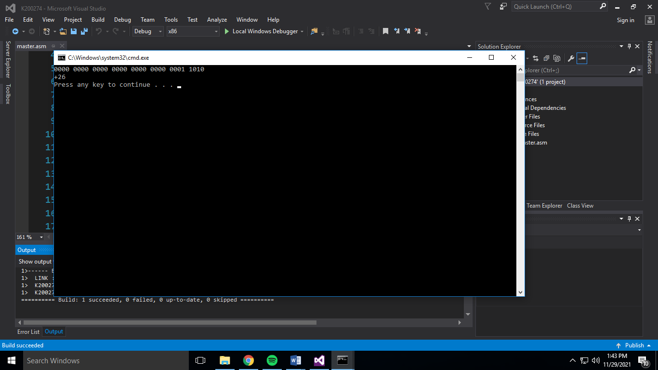

Q4)

INCLUDE Irvine32.inc

.data

str1 BYTE "Answer: ",0

.code

main PROC

mov ax,0

mov ax,1000000000000001b

mov bx, 0

shr ax,1

rcr bx,1

mov ax,bx

call writebin

call crlf

exit

main endp

END main

**Using SHRD**

Include Irvine32.inc

.code

Main PROC

mov eax,0

mov bx,0101 1011 0101 1011b

mov ax,0000000000000001b

shrd bx,ax,1

mov ax,bx

call writebin

call crlf

call writeint

exit

main ENDP

END main

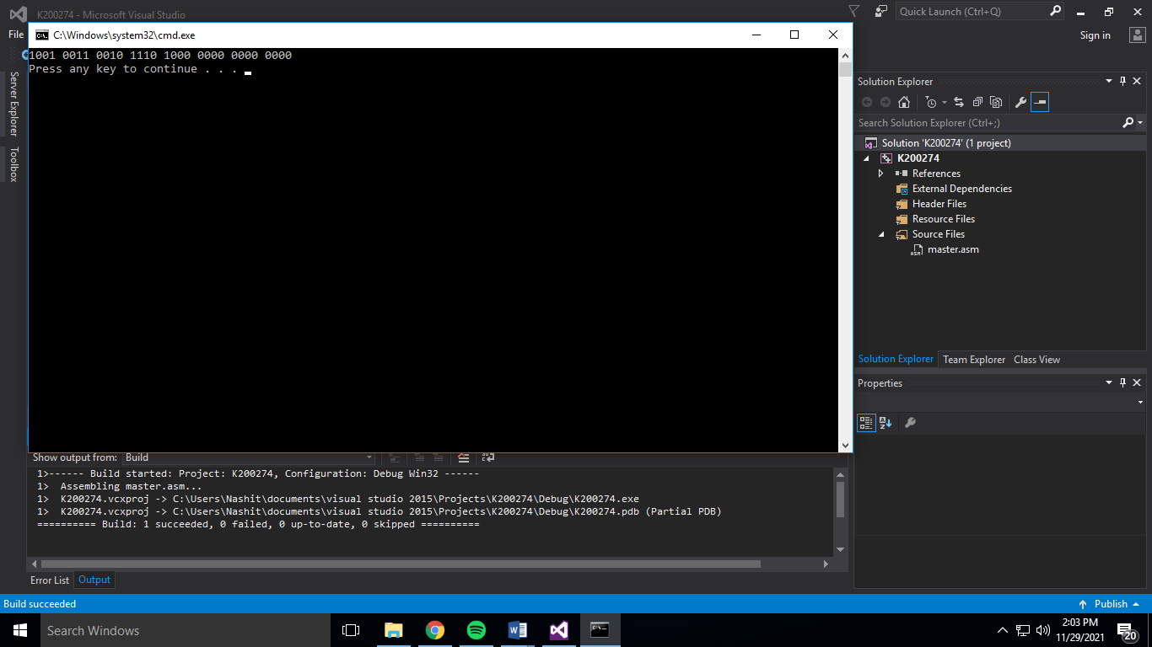

Q5)

include irvine32.inc

.data

val1 sdword 40

val2 sdword 20

val3 sdword 10

.code

main proc

mov ecx,0

mov eax,val2

cdq

idiv val3

mov ecx,eax

mov eax,val1

cdq

idiv val2

imul ecx

call writedec

call crlf

exit

main endp

end main

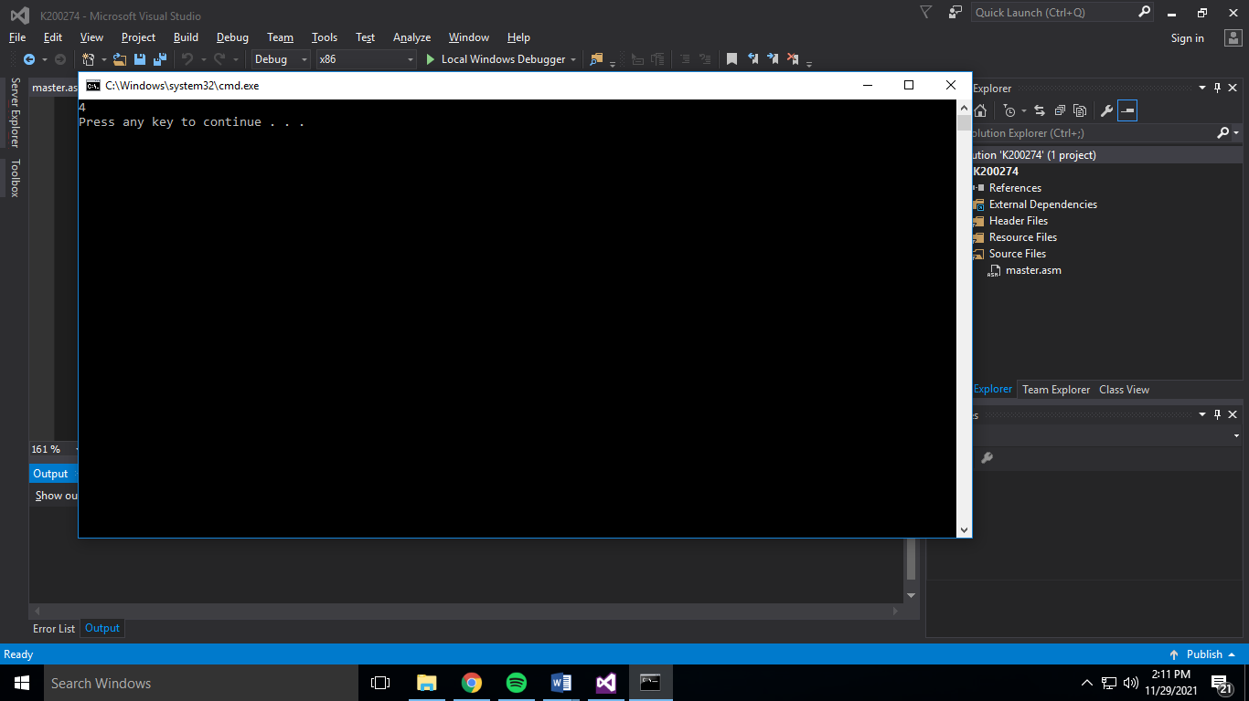

Q6)

Include Irvine32.inc

.DATA

val1 dword 0

val2 dword 0

.code

Main PROC

mov eax,10

mov ebx,20

push eax

push ebx

call Extended_add

exit

main ENDP

Extended_add proc

push ebp

mov ebp,esp

mov eax,[ebp+8]

mov ebx,[ebp+12]

add eax,ebx

call writedec

pop ebp

ret 8

Extended_add endp

END main

